# 

# 

# Investment Analytics

# FDI in INDIA

# written by : AMIT KUMAR

# Objective:

The main objective of this research is to understand the Foreign direct investment in India for the last 17 years from 2000-01to 2016-17. Investment is a game of understanding historic data of investment objects under different events but it is still a game of chances to minimize the risk we apply analytics to find the equilibrium investment. The dataset contains sector and financial year-wise data of FDI in India.

# Benefits:

Provides new approach to concealed patterns in the data.

• Helps avoid human biasness.

• To implement Naïve Bayes Classifier that classifies the disease as per the input of the user.

• Reduce the cost of medical tests.

Provides new approach to concealed patterns in the data.

• Helps avoid human biasness.

• To implement Naïve Bayes Classifier that classifies the disease as per the input of the user.

• Reduce the cost of medical tests.

Provides new approach to concealed patterns in the data.

• Helps avoid human biasness.

• To implement Naïve Bayes Classifier that classifies the disease as per the input of the user.

• Reduce the cost of medical tests.

Provides new approach to concealed patterns in the data.

• Helps avoid human biasness.

• To implement Naïve Bayes Classifier that classifies the disease as per the input of the user.

• Reduce the cost of medical tests.

Provides new approach to concealed patterns in the data.

• Helps avoid human biasness.

• To implement Naïve Bayes Classifier that classifies the disease as per the input of the user.

• Reduce the cost of medical tests.

Provides new approach to concealed patterns in the data.

• Helps avoid human biasness.

• To implement Naïve Bayes Classifier that classifies the disease as per the input of the user.

• Reduce the cost of medical tests.

Provides new approach to concealed patterns in the data.

• Helps avoid human biasness.

• To implement Naïve Bayes Classifier that classifies the disease as per the input of the user.

• Reduce the cost of medical tests.

Provides new approach to concealed patterns in the data.

• Helps avoid human biasness.

• To implement Naïve Bayes Classifier that classifies the disease as per the input of the user.

• Reduce the cost of medical tests.

Provides new approach to concealed patterns in the data.

• Helps avoid human biasness.

• To implement Naïve Bayes Classifier that classifies the disease as per the input of the user.

• Reduce the cost of medical tests.

Provides new approach to concealed patterns in the data.

• Helps avoid human biasness.

• To implement Naïve Bayes Classifier that classifies the disease as per the input of the user.

• Reduce the cost of medical tests.

Provides new approach to concealed patterns in the data.

• Helps avoid human biasness.

• To implement Naïve Bayes Classifier that classifies the disease as per the input of the user.

• Reduce the cost of medical tests.

# Provides new approach to concealed patterns in the data.

# Helps to understand the data on investment point of view.

# Helps to find variation in FDI on yearly basis.

# With the reference of previous investments can also forecast future trend of investment.

# Data Sharing Agreement

# Data file name fdi_in_india.csv

# **Number of column** - 18 columns

On transforming the data to tabular format we have 3 columns as,

# **Column names** :- >1. Sector  
 > 2. Fiscal Years  
 > 3. FDI value

here, Sector Column involves different industries such as :-

|  |  |
| --- | --- |
| * METALLURGICAL INDUSTRIES | |
| * MINING |
| * POWER | |
| * NON-CONVENTIONAL ENERGY | |
| * COAL PRODUCTION | |
| * PETROLEUM & NATURAL GAS | |
| * BOILERS AND STEAM GENERATING PLANTS | |
| * PRIME MOVER (OTHER THAN ELECTRICAL GENERATORS) | |
| * ELECTRICAL EQUIPMENTS | |
| * COMPUTER SOFTWARE & HARDWARE | |
| * ELECTRONICS | |
| * TELECOMMUNICATIONS | |
| * INFORMATION & BROADCASTING (INCLUDING PRINT MEDIA) | |
| * AUTOMOBILE INDUSTRY | |
| * AIR TRANSPORT (INCLUDING AIR FREIGHT) | |
| * SEA TRANSPORT | |
| * PORTS | |
| * RAILWAY RELATED COMPONENTS | |
| * INDUSTRIAL MACHINERY | |
| * MACHINE TOOLS | |
| * AGRICULTURAL MACHINERY | |
| * EARTH-MOVING MACHINERY | |
| * MISCELLANEOUS MECHANICAL & ENGINEERING INDUSTRIES | |
| * COMMERCIAL, OFFICE & HOUSEHOLD EQUIPMENTS | |
| * MEDICAL AND SURGICAL APPLIANCES | |
| * INDUSTRIAL INSTRUMENTS | |
| * SCIENTIFIC INSTRUMENTS | |
| * MATHEMATICAL,SURVEYING AND DRAWING INSTRUMENTS | |
| * FERTILIZERS | |
| * CHEMICALS (OTHER THAN FERTILIZERS) | |
| * PHOTOGRAPHIC RAW FILM AND PAPER | |
| * DYE-STUFFS | |
| * DRUGS & PHARMACEUTICALS | |
| * TEXTILES (INCLUDING DYED,PRINTED) | |
| * PAPER AND PULP (INCLUDING PAPER PRODUCTS) | |
| * SUGAR | |
| * FERMENTATION INDUSTRIES | |
| * FOOD PROCESSING INDUSTRIES | |
| * VEGETABLE OILS AND VANASPATI | |
| * SOAPS, COSMETICS & TOILET PREPARATIONS | |
| * RUBBER GOODS | |
| * LEATHER,LEATHER GOODS AND PICKERS | |
| * GLUE AND GELATIN | |
| * GLASS | |
| * CERAMICS | |
| * CEMENT AND GYPSUM PRODUCTS | |
| * TIMBER PRODUCTS | |
| * DEFENCE INDUSTRIES | |
| * CONSULTANCY SERVICES | |
| * SERVICES SECTOR (Fin.,Banking,Insurance,Non Fin/Business,Outsourcing,R&D,Courier,Tech. Testing and Analysis, Other) | |
| * HOSPITAL & DIAGNOSTIC CENTRES | |
| * EDUCATION | |
| * HOTEL & TOURISM | |
| * TRADING | |
| * RETAIL TRADING | |
| * AGRICULTURE SERVICES | |
| * DIAMOND,GOLD ORNAMENTS | |
| * TEA AND COFFEE (PROCESSING & WAREHOUSING COFFEE & RUBBER) | |
| * PRINTING OF BOOKS (INCLUDING LITHO PRINTING INDUSTRY) | |
| * COIR | |
| * CONSTRUCTION (INFRASTRUCTURE) ACTIVITIES | |
| * CONSTRUCTION DEVELOPMENT: Townships, housing, built-up infrastructure and construction-development projects | |
| * MISCELLANEOUS INDUSTRIES | |

# Architecture

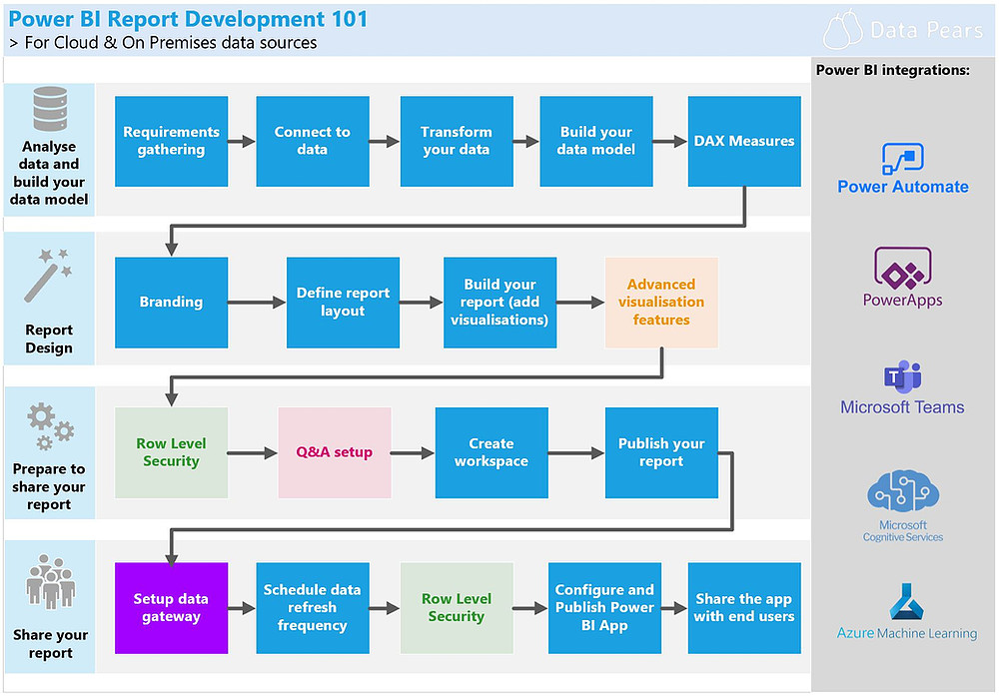

**1) Analyze data and build your data model**

# Requirements gathering

This is one of the most important steps in any reporting project! Before you start to build anything, you need to understand your user's requirements and understand the data you will have available .So in my case the requirement was to understand the the Foreign direct investment in India for the last 17 years from 2000-01to 2016-17. Investment is a game of understanding historic data of investment objects under different events but it is still a game of chances to minimize the risk we apply analytics to find the equilibrium investment. The dataset contains sector and financial year-wise data of FDI in India.

# Connect to data

With power bi, I have connected to data source in excel , named as fdi_in_india.csv

# Data Transform

Data is cleaned and transformed in power query editor , shaped the data to meet our reporting needs. columns name has been changed accordingly, data types were also changed accordingly.

# Build your data model

Creating a great data model is one of the most important tasks that an analyst can perform in Power BI. By doing this job well, you help make it easier for people to understand and use your data, which will make building valuable Power BI reports easier for them and for you.

The idea in this step is for you to design a data model that is intuitive, high-performing and simple to maintain.

# DAX Measures

In this step, we are going to create the business logic behind the figures we want to present in our report using DAX.

Data Analysis Expressions (DAX) is a programming language that is used throughout Microsoft Power BI for creating calculated columns, measures, and custom tables.

here i have used DAX function to find out some valuable insight from data .

# **2)** Report design

Report design is not just about adding charts and slicers, it's about presenting information.

# Branding

Choose color theme

One of the key things when creating your Power BI report design is the color scheme/theme. Colors, when used correctly, can make an average report look very compelling and insightful!

# Define Report Layout

In this step, we are going to define how we are going to display and organize the information in our report.

To achieve this, I'm going to introduce a concept I love, and that will help you on this journey: the Star schema design.

# **Build your report (add visualizations)**

Visuals allow you to share data insights more effectively and increase comprehension, retention, and appeal. They are a fundamental part of your report because they help your audience connect and interact with the information to make informed business decisions quickly.

# # ****Advanced visualization features (Optional)****

This is the step where we tie everything we've done so far in terms of report design together. Here, we will be looking at some final details such as visual interactions, defining bookmarks, building custom tooltips, drill through and others.

**3)** Publish your report

Once BI reports are created in Power BI desktop, you can also share the reports with other business users. All BI reports, dashboards, and data can be shared with other colleagues and business users in the organization.

You can share reports using the following methods −

* Publish reports using Power BI Service
* Content Packs combine dashboard, report, and datasets obtained in BI desktop tool
* Create Groups and assign specific rights to different users for report sharing
* Use Power BI mobile apps to access share dashboards and reports.
* We can also export the report as a PDF file .
* we can export the report as power bi template.

# Q & A:

Q1) What’s the source of data?

sol: The fdi_in_india.csv is the source .

Q 2) What was the type of data?

sol: The data was the combination of numerical and Categorical values.

Q 3) What’s the complete flow you followed in this Project?

sol: Refer page 5th for better Understanding.

Q4) How did you transformed the data?

sol: Data is cleaned and transformed in Power query editor. Columns name has been changed accordingly, data types were also changed accordingly. New custom columns has been created via the help of DAX function in order to find out valuable insights from the data.